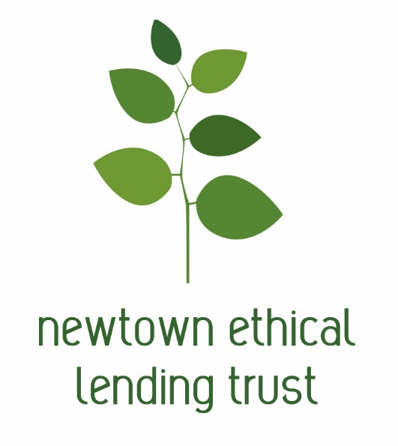

Who we are
The Newtown Ethical Lending Trust (NELT) is a registered charitable trust that has been making interest-free loans to the Greater Wellington community since 2012.
The trust was launched in collaboration with local budgeting services and members of the community dedicated to helping Wellington families gain financial independence.
We are completely not-for-profit, and rely on external grants and donations to operate.

What we do
We make interest-free loans to people in need in the Greater Wellington region as an ethical alternative to high-interest lenders. Our loans are interest-free, with no fees or hidden costs.
We offer loans to people on low incomes for essential goods and services such as car repairs, medical expenses and household items like washing machines. We may also be able to help if you have existing debt that is unmanageable.
We pay directly to creditors, and then borrowers pay us back at affordable rates over a period of up to 2 years. As soon as repayments start coming in, we can lend that money to other people in our community that need it.
In this way, a small amount of money can help multiple individuals and families become debt-free.

How to Apply

You need to be working with a budget adviser or financial mentor to apply for a loan, please contact us if you would like us to put you in contact with such a service – our email address is admin@ethical-lending.nz
To apply you will need to complete our application form. The application form is available on our website www.ethical-lending.nz/application-forms/ and contains a checklist of documents which you need to supply with your application:
Please check that all required supporting documentation is included:

Covering letter from your Advisor supporting your application
Current budget (form available on our website)
New budget (including the proposed loan from Newtown Ethical Lending Trust) that shows your ability to make the repayments
Debt schedule showing ALL balances owing, repayment rate, any arrears and purpose of loan (form available on our website)
Bank statements for ALL bank accounts held by the applicants (for the last three consecutive months)
Loan statements for ALL loans and other debts owing by the applicants (for the last three consecutive months)
Documentation showing the creditors to be paid, the amounts to be paid and their bank account details
AP / benefit / income redirection documentation for NELT loan repayments
Evidence of Income and any other payments received – at least last two wage slips or WINZ benefit breakdown
Details of what cash withdrawals over $100 shown on your bank statement were spent on
Evidence of any expenses not shown on bank statement
Copy of photo ID (e.g. driver licence, passport) signed by the Budget Advisor as a genuine copy of the original

You will need to provide a budget showing your income and expenses. You will also need to provide a list of any debts you have. The budget form and debt schedule form are also available on our website.
If you need assistance completing these forms your Budget Advisor will be able to help.
The more complete the application and especially your budget and debt schedule the easier it will be to make a quick decision on granting a loan.
When your application is completed please post the form plus all supporting documentation to PO Box 14221, Kilbirnie, Wellington 6241 or scan and email the documents to admin@ethical-lending.nz
If we have any questions we will contact you, loan decisions typically take 10 working days plus any additional time elapsed while awaiting answers to any questions we might ask you or while waiting for any additional information sought from you.
If you have any questions for us please email admin@ethical-lending.nz

