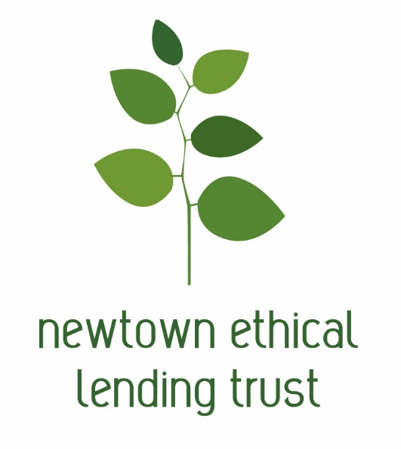

Who we are
The Newtown Ethical Lending Trust (NELT) is a registered charitable trust that has been making interest-free loans to the Wellington community since 2012.
The trust was launched in collaboration with the Newtown Community & Cultural Centre, local budgeting services and members of the community dedicated to helping Wellington families gain financial independence.
We are completely not-for-profit, and rely on external grants and donations to operate.

What we do
We make interest-free loans to people in Wellington as an ethical alternative to high-interest lenders. Our loans are interest-free, with no admin fees or hidden costs.
We offer loans to people on low incomes for essential goods and services such as car repairs, medical expenses and household items like washing machines. We may also be able to help if you have existing debt that is unmanageable.
We pay directly to creditors, and then borrowers pay us back at affordable rates over a period of up to 2 years. As soon as repayments start coming in, we can lend that money to other people in our community that need it.
In this way, a small amount of money can help multiple individuals and families become debt-free.

How to Apply
To apply you will need to complete our application form. The application form is included in this pack and contains a checklist of documents which you need to supply with your application:
If you have a Budget Advisor then please include a covering letter from your budget advisor supporting your application
A Budget that shows your ability to make the repayments. Please indicate the existing amounts paid that will be replaced with the loan from NELT
A current bank statement (last 90 days) for all bank accounts held by the applicants
AP / benefit / income redirection documentation for NELT loan repayments
Documentation showing the creditors to be paid, the amounts to be paid and their bank account details
Evidence of Income and any Working for Families payments if not shown on bank statement
Evidence of any expenses not shown on bank statement
Details of any outstanding debt not included in the creditors to be paid including documentary evidence
Certified copy of photo ID (e.g. driver licence, 18+card, passport).
You will need to provide a Budget showing your income and expenses. You will also need to provide a list of any debts you have. The budget form and debt schedule form is included in this pack, it is also available online at:
http://www.familybudgeting.org.nz/get-budgeting-advice/budgeting-resources/
If you need assistance completing these forms you could seek advice help from a Budget Advisor.
You can find a Budget Advisor in your area online at:
http://www.familybudgeting.org.nz/get-budgeting-advice/
You can also speak with a Budget Advisor by calling the Freephone Budgetline 0508 BUDGETLINE (0508 283 438)
The freephone service is attended from 8.00am – 4.30pm Mondays to Fridays. A message can be left on the answerphone at other times, or if the phone is busy, and a budget adviser will call you back as soon as possible.
The more complete the application and especially your budget and debt schedule the easier it will be to make a quick decision on granting a loan.
When your application is completed please post the form plus all supporting documentation to PO Box 7021, Newtown, Wellington or scan and email the documents to admin@ethical-lending.nz
If we have any questions we will contact you, loan decisions typically take 10 working days plus any additional time elapsed while awaiting answers to any questions we might ask you or while waiting for any additional information sought from you.
If you have any questions for us please email admin@ethical-lending.nz

